UNIVERSITY OF DAR ES SALAAM


COLLEGE OF INFORMATION AND COMMUNICATION TECHNOLOGY
DEPARTMENT OF ELECTRONICS AND TELECOMMUNICATIONS ENGINEERING
FINAL YEAR REPORT-MID SEMESTER TWO
PROJECT TITLE: DESIGN AND IMPLEMENTATION OF AN AUTOMATIC ID CARD ISSUANCE SYSTEM

Student’s Name: Samuel Dan Musyani
Registration Number: 2022-04-09050
Supervisor’s Name: Dr. Hashimu Iddi

ABSTRACT
The issuance of student identification cards in many higher learning institutions is often characterized by long processing times as a result of manual verification within a narrow working window. This project proposes the design and implementation of an automated self-service student ID card issuance system aimed at improving efficiency, security and all-time reliability of issuance process. The system is an embedded system with peripheral devices for user authentication, data collection, card issuance, back-end communication together with database access. The proposed project will be evaluated based on authentication success rate, dispense rate, issuance accuracy, and system’s reliability.
The outcome of this project is expected to be a functional prototype demonstrating an automated secure student ID card issuance system suitable for University environments.

TABLE OF CONTENTS
ABSTRACT ii
TABLE OF CONTENTS iii
LIST OF TABLES v
LIST OF FIGURES vi
LIST OF ABBREVIATIONS vii
CHAPTER ONE: INTRODUCTION 1
1.1 BACKGROUND 1
1.2 PROBLEM STATEMENT 1
1.3 MAIN OBJECTIVE 1
1.4 SPECIFIC OBJECTIVE 1
1.5 SIGNIFICANCE OF STUDY 2
1.6 SCOPE AND LIMITATIONS 2
CHAPTER TWO: LITERATURE REVIEW 3
2.1 RELATED PROJECTS 3
2.2 RESEARCH GAP 3
CHAPTER THREE: SYSTEM DESIGN AND METHODOLOGY 4
3.1 SYSTEM ARCHITECTURE 4
3.2 FUNCTIONAL WORKFLOW 5
3.3 COMMUNICATION PROTOCOL 7
3.4 SYSTEM CIRCUIT DESIGN AND ITS ARCHITECTURE 7
3.4.1 COMPONENTS USED 7
3.4.2 HARDWARE CIRCUIT ARCHITECTURE 8
3.4.3 POWER REGULATION 8
3.4.4 STM32 CORE CIRCUIT DESIGN 9
3.4.5 MOTOR DRIVER AND ACTUATION CIRCUIT DESIGN 10
3.5 COMPUTER VISION DESIGN INTEGRATION 10
3.5.1 DESIGN DETAILS 10
3.5.2 PROCESSING PIPELINE 11
3.6 BACK-END AUTHENTICATION DESIGN 11
3.6 MECHANICAL DESIGN 12
3.7 PROJECT SCHEDULE 12
3.8 PROJECT BUDGET 13
CHAPTER FOUR: SOFTWARE IMPLEMENTATION AND CIRCUIT SIMULATION 15
4.1 SOFTWARE IMPLEMENTATION 15
4.2 CIRCUIT SIMULATION 16
4.2.1 REVERSE POLARITY CIRCUIT 16
4.2.2 BUCK CONVERSION CIRCUITS 17
4.2.3 MOTOR DRIVER CIRCUIT SIMULATION 20
CHAPTER FIVE: CONCLUSION 21
REFERENCES 22

LIST OF TABLES
Table 1: Project Budget 13

LIST OF FIGURES
Figure 1: System’s block diagram 4
Figure 2: Staff-side functional workflow 6
Figure 3: Student-side workflow 6
Figure 4: Reverse polarity circuit 8
Figure 5: LMZ23610 schematic design for 5V output. 9
Figure 6: PTSM82903 schematic design for 3.3V output. 9
Figure 7: Motor driver connection schematic 10
Figure 8: Processing pipeline workflow 11
Figure 9: Circular storage chamber 12
Figure 10: Semester 1 activity plan (Gantt Chart) 13
Figure 11: Semester 2 activity plan (Gantt Chart) 13
Figure 12: Sample card detected (green line shows detection) 15
Figure 13: Anchor-ROI localization of sample card 16
Figure 15: Text extraction and processing performances 16
Figure 15: Correct input polarity 17
Figure 16: Wrong input polarity 17
Figure 17: LMZ23610 simulation results at startup 18
Figure 18: LMZ23610 simulation results at steady state 18
Figure 19: PTSM82903 simulation results at start up 19
Figure 20: PTSM82903 simulation results at load transient 19
Figure 21: 0011 and 1000 test signals (from MCU) to motor driver 20

LIST OF ABBREVIATIONS
ABBREVIATIONS | LONG FORM
2FA | 2-Factor Authentication
API | Application Program Interface
CAD | Computer Aided Design
CLK | Clock
CS | Chip Select
DB | Database
GB | Gigabyte
ID | Identification
IoT | Internet of Things
MISO | Master In Slave Out
MOSI | Master Out Slave In
OCR | Optical Character Recognition
OS | Operating System
OTP | One Time Password
PVC | Poly-Vinyl Chloride
PWM | Pulse-Width Modulation
RAM | Random Access Memory
SMS | Short Message Service
SPI | Serial Peripheral Interface
Wi-Fi | Wireless Fidelity

CHAPTER ONE: INTRODUCTION

1.1 BACKGROUND
Universities commonly issue student ID cards that serve as proof of registration and campus identification for various services to students. At the University of Dar es Salaam, the card collection process, which occurs immediately after students have completed registration, involves queuing at the responsible office for collection. However, for a high volume of students, this results in long waiting times, narrow service windows (only operating during working hours), and staff exhaustion.
Therefore, the project aims to develop a prototype of an Automated ID Card Issuance System that sorts and gives out pre-printed ID cards to students on demand at all times. The system integrates a microcontroller that controls actuators in real-time, a single-board computer that performs computer vision (for ID identification), student’s identity authentication, logging of various activities, and back-end integration. The intended solution aims to reduce distribution time while ensuring secure ID card distribution as it is.

1.2 PROBLEM STATEMENT
The current student ID card issuance process at University of Dar es Salaam involves a waiting period of approximately one week after registration due to delayed card availability in the individual’s college. After release, the card collection also requires students to queue and sort a bunch of ID cards. So, for a high volume of students, the staff responsible suffers significant work strain. On top of that, fixed hours also hinder the sorting capacity of students' issuance per time. As a result, card issuance for registered students takes up to several days, which may bring inconvenience to students.

1.3 MAIN OBJECTIVE
Design and implementation of an Automated ID Card Issuance System for pre-printed student ID cards with secure authentication and audit logging while serving students at all times.

1.4 SPECIFIC OBJECTIVE
- To implement a reliable control system for actuators using a microcontroller capable of selecting and dispensing a single card from a pile of cards in a stored compartment.
- To implement a computer board application that gives out authentication OTPs, verifies the student’s set pin, receives the user registration data, verifies it against a database, and communicates the command to the microcontroller.
- To implement robust logging of each transaction details in database for auditing and debugging.
- To implement security policy that uses SMS-delivered OTPs as authentication mechanism, and also enforce measures to deal with invalid attempts and communication to system admin.
- To evaluate system performance using metrics such as average card retrieval time, authentication success, error handling and dispense rate.
- To produce a formal report involving design of the prototype at various milestones.

1.5 SIGNIFICANCE OF STUDY
- Operational efficiency: the proposed system reduces long queues and waiting times by allowing students to retrieve ID cards on demand without any staff intervention.
- Reduced administrative burden: the system performs automation which replaces the repetitive tasks done by a university staff allowing them to focus on higher level tasks.
- Scalability, accessibility and replicability: Although the proposed system is implemented as a prototype for UDSM, the system can be adopted by other institutions such as banks for card applications. Also, access to students retrieving their ID cards beyond standard normal working hours.
- Academic contribution: the project demonstrates practical application of embedded systems, back-end software and other mechanical design theory and automation studied as theory in various academic year(s).

1.6 SCOPE AND LIMITATIONS
This project focuses on the design and implementation of an Automated ID Card Issuance System which integrates the software part (back-end, user interaction and computer vision verification) and hardware part with microcontroller and actuators for card sorting and dispensing the said card. Therefore, the prototype does not implement on-device printing of the PVC cards, mobile application or payment gateway.
The system intends to use a mock database for testing unless institutional access is granted.

CHAPTER TWO: LITERATURE REVIEW
In this chapter, various existing systems, projects and technologies related to the proposed project are reviewed. The purpose of the review is to understand different approaches, scope, limitations and gaps and hence, establish basis of the proposed project. Therefore, the following points gathered below feature ideas with similar concepts as the proposed project.

2.1 RELATED PROJECTS
- Automatic and Smart Vending systems: these are some self-service systems that provide mostly goods (foods) to users without much human intervention, mostly observed in supermarkets for snacks and beverages. These systems have two categories: non-IoT machines, which operate by giving physical cash to the machine, and IoT machines, which work with cashless payments and track the availability of stock, locations to satisfy customer preferences by using microcontrollers (Ratnasri & Sharmilan, 2021). Also, some vending systems apply image processing with deep learning to detect and categorize various target objects of interest in the image. These kinds of vending machines also implement a weight data acquisition part to increase the accuracy of target object detection (Xia, K., Fan, H., Huang, J., Wang, H., Ren, J., Jian, Q., & Wei, D).
- System architectures and control strategies: in most of the dispensing applications, generally a microcontroller is used with a communication module, mostly Wi-Fi, with a logic to directly manage actuator control, sensor inputs, safety interlocks, and communicate with the server or a computer for other complex tasks (Prasad, Kumar, Shriram, Prof. Dr. Mane, 2024).
- Authentication and security: this is one of the most critical part of the system that deals with sensitive items. In automated environments, combining multiple verification layers (e.g OTP, biometrics, card scanning) improves security. In ATM systems, work on authentication explores multi-factor approaches, integrating OTPs with biometric factors to reduce unauthorized access risk (Kibaya, Lubobya, 2024).

2.2 RESEARCH GAP
From the related projects, the proposed system aims to cover the gap that despite an extensive research on vending and kiosk systems, limited number of projects addresses secure low-cost automated distribution of pre-printed identification cards particularly in University environments.

CHAPTER THREE: SYSTEM DESIGN AND METHODOLOGY
This chapter reviews various procedures to design, build and evaluate the performance of the prototype. It covers system architecture, hardware and software selection together and security.

3.1 SYSTEM ARCHITECTURE
High-level controller will be used to control the user interface, network connectivity, 2FA for OTP and student’s pin, database access, computer vision verification, transaction logging, and command issuing to the real-time controller. Then, a real-time controller will be used to directly control the motor, safety monitoring (limit switches), status reporting, and mechanical card sorting and ejection.
The pre-printed cards will be organized in indexed storage sections, which will be mapped to existing barcodes on the ID cards. Local (mock) database will be used to replicate the University DB scheme, and testing will emulate that unless permission is granted to access the database (API).
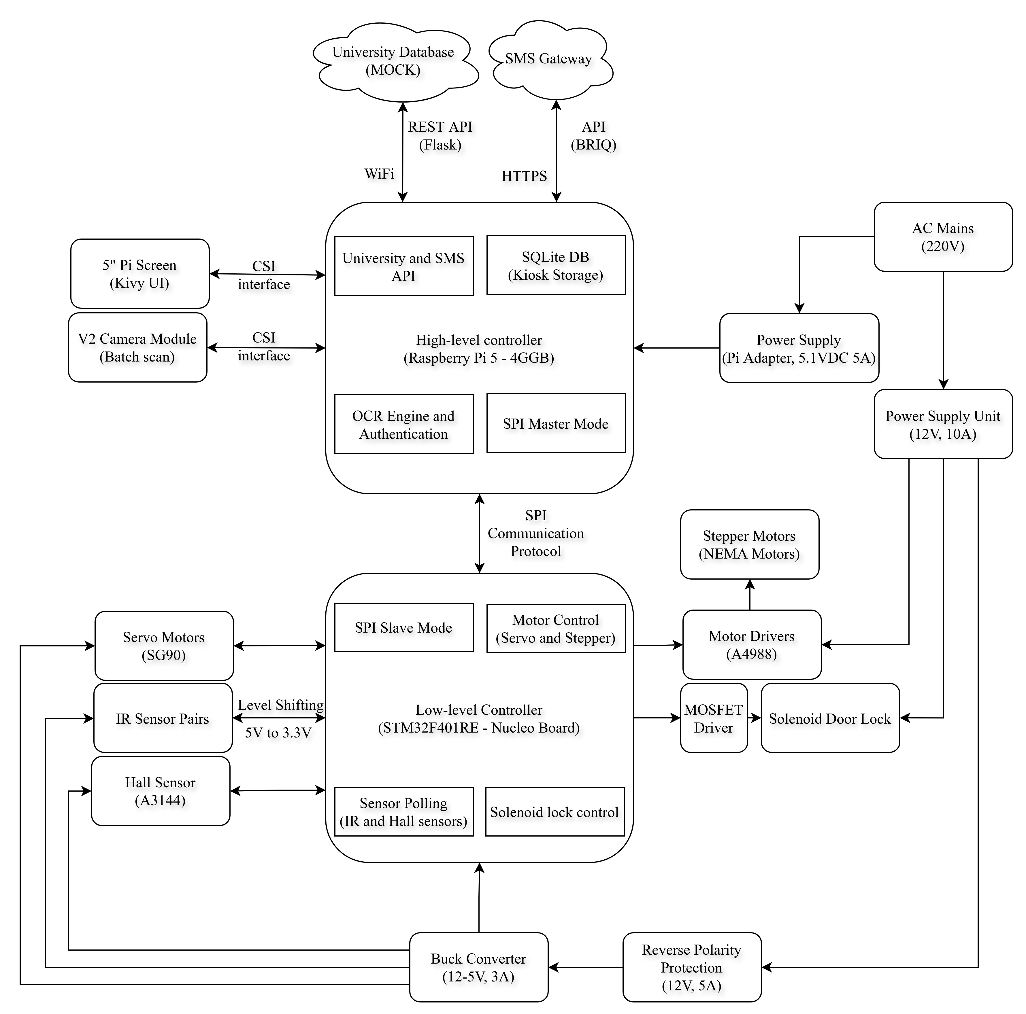
Figure 1: System’s block diagram

3.2 FUNCTIONAL WORKFLOW
- Preload phase: responsible staff inserts a bunch of pre-printed cards into the dispenser, then the machine runs a routine scan and maps each card into a slot index in the dispenser DB. The high-level controller records the mapping with the individual card.
- Notification phase: when the cards are available, right after the routine scan, the high-level controller initiates triggering of SMS to particular students. The SMS includes an OTP valid for one retrieval attempt. If it is the particular student’s first time use, and extra different and temporary pin is sent via SMS for 2FA.
- Retrieval phase: First, students scan their expired card, and their information is shown on the screen (registration number, name, and degree programme), then an OTP prompt follows, as received from the SMS. Thereafter, the high-level controller validates the OTP and prompts for the student’s pin for extra layer of authentication. If it is the student’s first time use, after the prompt, the system gives a form to register a new custom pin which will be permanent for each individual.
After that, high-level sends the dispense command to the low-level controller to start the card dispensing process. The low-level microcontroller executes the motion to retrieve the card and verifies the card and its presence, and performs ejection while updating and returning the status to the high-level controller. Lastly, the high-level controller logs the transaction to the database as the audit logs.
- Security measures: after 3 invalid attempts for the same registration number within the same session, the system flags that particular number as locked for amount of time, notifies the system admin and returns to the home screen. In addition to that, in case of any physical tampering, the system alerts the admin and shuts down until manual admin reset is performed.
Below are the functional workflows featuring both student-side and staff-side access of the system:
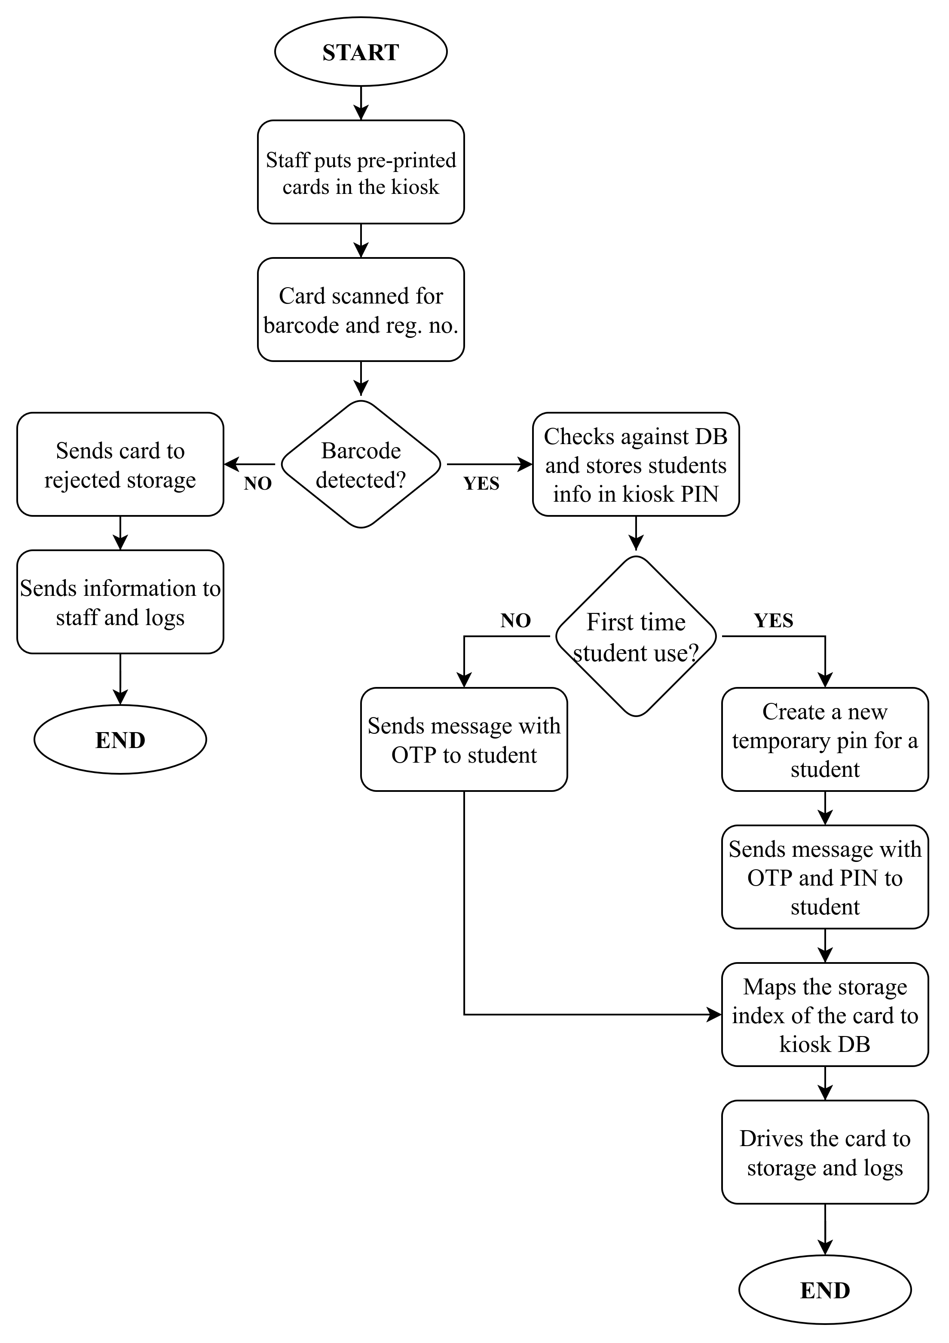
Figure 2: Staff-side functional workflow
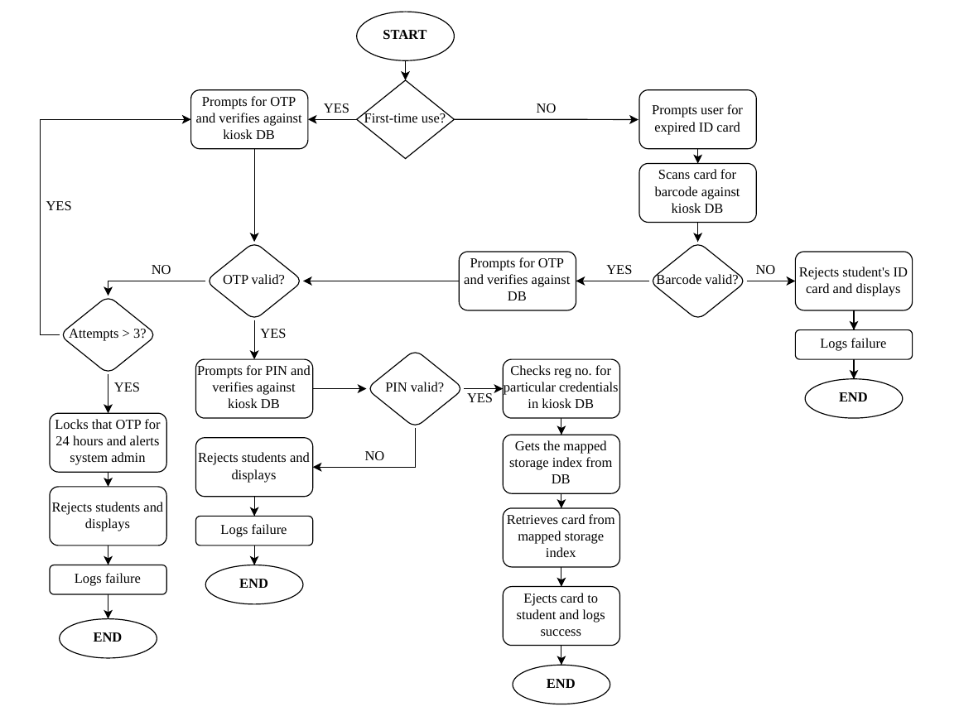
Figure 3: Student-side workflow

3.3 COMMUNICATION PROTOCOL
The communication protocol targeted between high-level controller and low-level controller is SPI, which has four wires (CLK, MOSI, MISO, CS) plus common ground, where Raspberry Pi is the master, with STM32 as its slave. All these communication signals operate at 3.3V.
This communication protocol was selected due to high speed synchronous communication, full-duplex capability, simple hardware implementation and very reliable short distance communication.
Within this protocol, the commands (light messages) will be the ones to initiate various activities by the high-level controller through low-level controller done by the actuators.

3.4 SYSTEM CIRCUIT DESIGN AND ITS ARCHITECTURE

3.4.1 COMPONENTS USED
The hardware and software tools selected for this project were chosen based on their performance requirements, need for scalability and compatibility with each other.
- Raspberry Pi 5 (4GB RAM): hosts back-end application, OTP generation, database access, logging, computer vision and communication with low-level controller.
- STM32F401RE – Nucleo Board: directly drives actuators, reads sensors, timing and safety logic, detects mechanical faults and reports status to Raspberry Pi.
- Camera module – Pi Camera V2: visual images for card to support computer vision tasks.
- Actuators – NEMA 17: Move sorting mechanisms, control card selection and ejection.
- Motor drivers - A4988: amplify control signals to drive motors safely.
- Sensors: identify various conditions, detect jams and misalignments.
- Power Supply: provides regulated power to components of the system
The following are the software proposed to be used in this project:
- Raspberry Pi OS: supporting system of the high-level controller.
- Back-end Application: handles user input, authentication, interfaces with database, sends commands to low-level controller and manages error handling.
- Database: stores students data and logs.
- Computer Vision libraries: supports card insertion and ejection verification.
- Low-level controller Firmware: executes motor control routines, reads sensors, implements communication and monitors safety.

3.4.2 HARDWARE CIRCUIT ARCHITECTURE
The hardware part of the Automated ID Card Issuance System is designed to support controlled mechanical actuation, stable power distribution and reliable communication between controllers. The circuit design was developed using Altium. The architecture design is divided into various design modules which include power regulation sub-system, STM32 core circuit control circuit, motor driver and actuation circuit and communication circuit interface.

3.4.3 POWER REGULATION
The system uses two controllers using different voltage levels (5V-Raspberry Pi and 3.3V-STM32) each with its own maximum current capabilities. The design of the system has one source of power with 12V and 8A current capabilities. The power source is equipped with a reverse polarity protection circuit for protection as shown below:
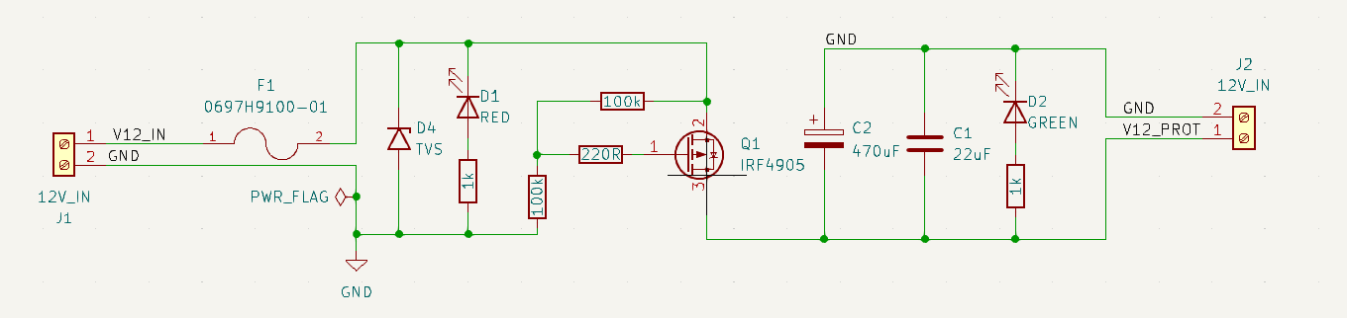
Figure 4: Reverse polarity circuit
The aim of this circuit is to prevent any damage which may be caused by exchange in polarity connections in the input. Thus, this configuration is expected to give zero output voltage when the input polarities are not in order.
In addition to that, 12V from the power source is stepped down by buck converters each to its desired parameters. For 5V voltage level, the design implemented the use of LMZ23610 buck converter with a current rating of 10A for thermal margin mainly. The schematic design as instructed from the data sheet is as shown below:
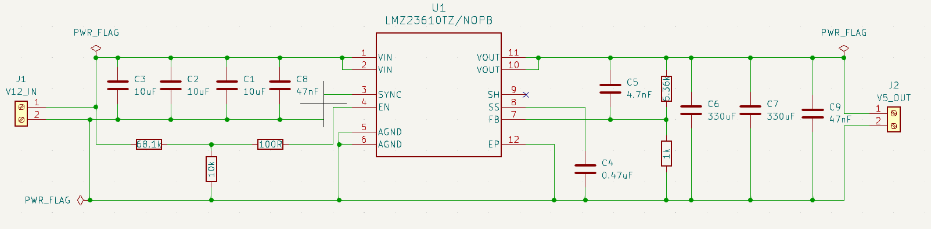
Figure 5: LMZ23610 schematic design for 5V output.
Moreover, for 3.3V voltage level, the design was implemented by using a PTSM82903 buck converter with current capability of 3A for thermal margin. This ensures the input voltage at 12V is stepped down to the desired level 3.3V with a stable output due to its load regulation capacity. The schematic design was as instructed from the data sheet to give out the desired results:
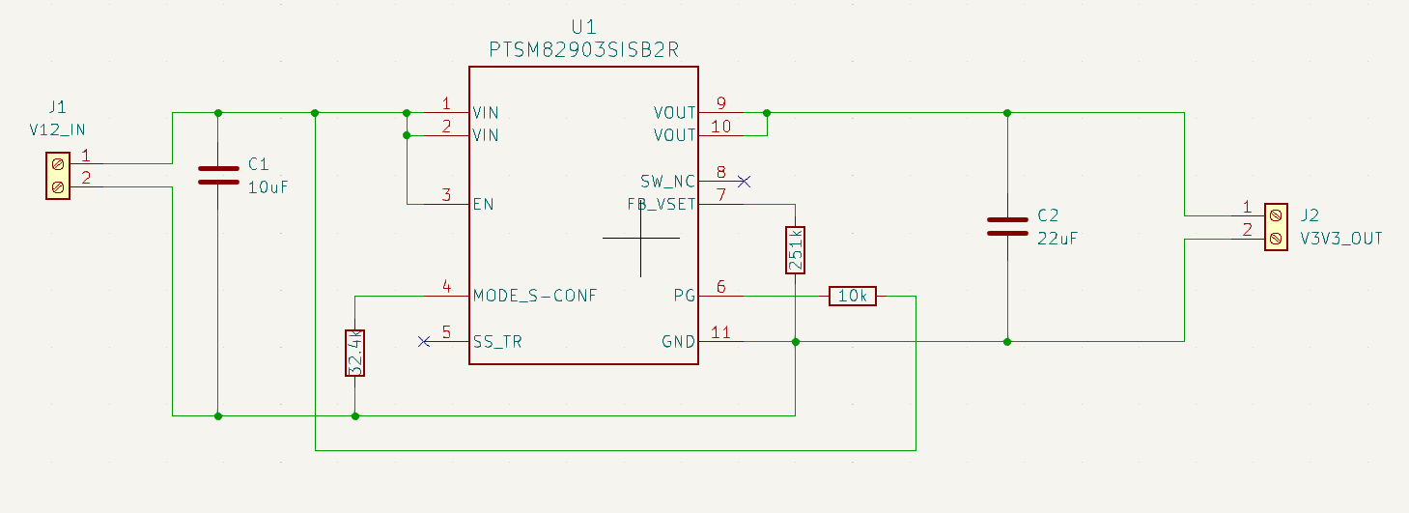
Figure 6: PTSM82903 schematic design for 3.3V output.

3.4.4 STM32 CORE CIRCUIT DESIGN
The STM32 controller defines a real-time control of the system’s actuation and deterministic behaviours. Therefore, the core design includes: proper power supply connections with decoupling capacitors to reduce power supply variations and configuration of boot pins.
STM32 programming interface application to be used will be STM32CubeMX, together with STMicroelectronics IDE together to program a low-level microcontroller used. At this stage, those applications uses a way of debugging that needs a hardware (chip or board) which is not yet implemented. On the next stage of this project, programming and implementation of the project will follow along.

3.4.5 MOTOR DRIVER AND ACTUATION CIRCUIT DESIGN
The actuation sub-system is designed to control DC stepper motors responsible for card transport and dispensing. The motor driver circuit is designed to interface with an MCU (STM32) through various control inputs and enable logic to drive the motors efficiently.
The motor driver power supply is the 5V power rail which is electrically separated from the logic. Below is the schematic diagram showing the connection configuration of the motor driver driving the stepper motor from logics of the micro-controller. This motor driver circuit is designed to also accept dual power sources, either from an adapter or a terminal block.
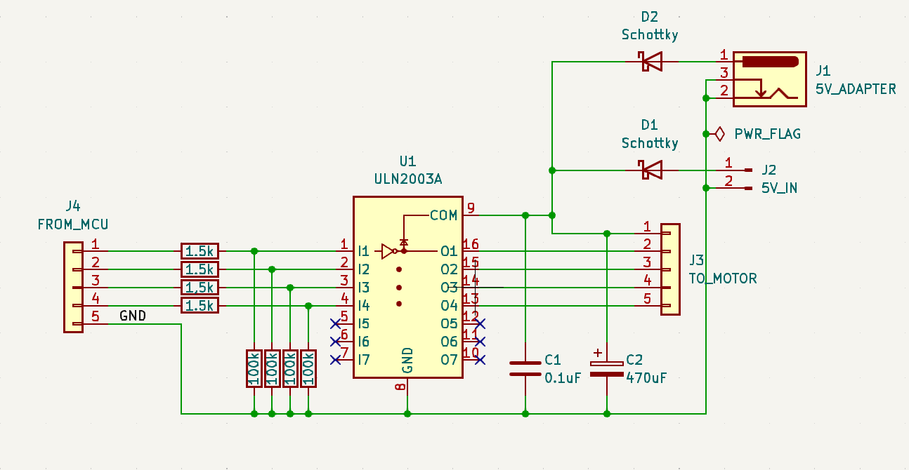
Figure 7: Motor driver connection schematic

3.5 COMPUTER VISION DESIGN INTEGRATION
The computer vision module’s aim is to detect and extract information from the inserted cards, either by the students or staffs. It performs OCR-based extraction of student’s registration number. The extracted data was chosen to be the registration number because it is unique for each student with no duplicate complications.

3.5.1 DESIGN DETAILS
The initial barcode-verification revealed some sensitivity to orientation variation and reflection hence OCR-based design was selected to reduce dependency on alignment of the card with lights and flexibility since text are relatively larger hence easier to identify than the barcodes.

3.5.2 PROCESSING PIPELINE
The proposed system design factored the PI camera capturing images of the cards, and the high-level controller processing them to extract the registration via OCR-based detection methods. Therefore, the processing pipeline consists of the following stages:
Figure 8: Processing pipeline workflow
From the functional workflow, card detection is designed using edge detection and contour extraction techniques which are filtered according to geometric constraints such as minimum area and aspect ration according the CR80 standard card size. Once a contour is detected, a perspective transformation is done to obtain a clear frontal view of the card to improve OCR detection stability.
To avoid relying solely on pixel coordinates, the design used incorporated anchor-based localization with a known reference on the card used “NAME”. After locating the reference, relative offsets (in pixels) are applied to extract the region where the registration number is expected to be from the anchor chosen.
The extracted region is processed used OCR, and configured to prioritize numeric text recognition first. Then, after extraction by OCR, the expected format of registration number “YYYY-NN-XXXXX” is validated. Only the text that fits the description of format is considered as success.

3.6 BACK-END AUTHENTICATION DESIGN
The back-end system is designed to manage identity validation, authentication control and system logging for audits. Therefore, it acts as a bridge between the computer vision results and the low-level controller activities. If the authentication goes wrong, low-level controller cannot perform any mechanical activity. The sub-system performs three important services:
- Student verification service
- OTP Authentication service
- Audit logging service.
After a successful extraction of the registration number from computer vision processes, the back-end verifies the number against the University database and fetches information about the particular student and stores the registration number to the local system’s database. Only valid and active records are passed to authentication.
The main authentication mechanism is based on a One-Time Password (OTP) model. Each OTP produced is designed according to standard security principles:
- Randomized OTP generation
- Secure storage using hashing
- Time-limited validity
- Restricted number of attempt.
The OTP delivered to the student using a SMS gateway. During retrieval, the student inputs the received OTP through the user interface designed. Back-end then compares the hashed input against the stored and logs the action in either case, failure or success. The logging design ensures accountability and traceability.

3.6 MECHANICAL DESIGN
As the system requires a staff to load a pile of cards into a machine, and it sorts out each card according to the information and stores it, here is the design of it. The card sorting and storage system, will be a combination of servo motor and a circular bin calculated with each slot to an assigned mapped number stored in the system’s database. If the card is needed, the bin is rotated by the servo motor up to the calculated position and a card is taken/ejected from the bin.

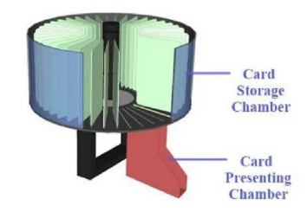
Figure 9: Circular storage chamber

3.7 PROJECT SCHEDULE
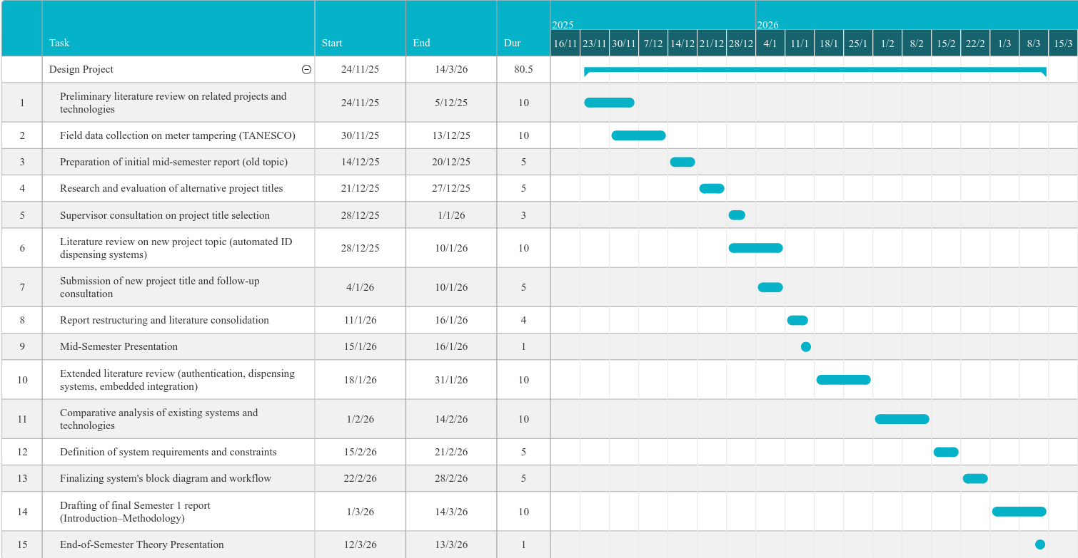
For first semester, the following Gantt chart shows various activities planned for proposed system:
Figure 10: Semester 1 activity plan (Gantt Chart)
For second semester, the following Gantt chart shows various activities planned for proposed system:
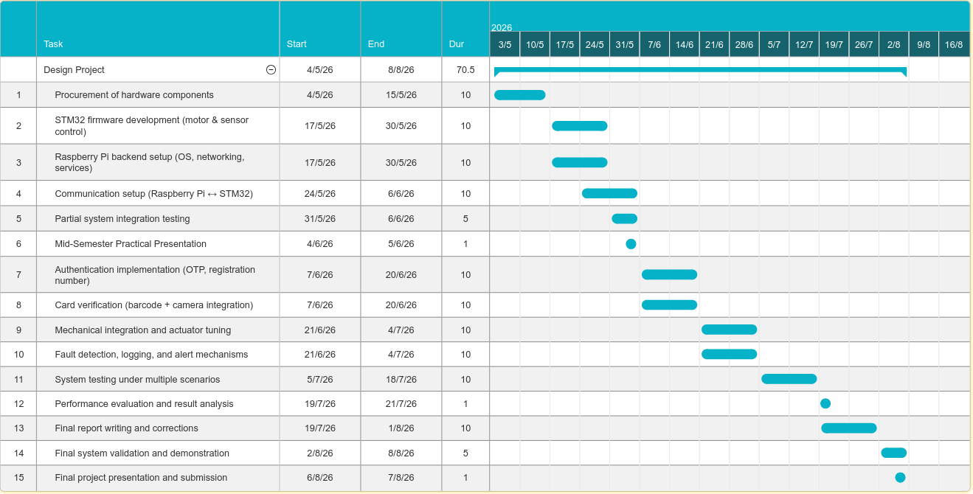
Figure 11: Semester 2 activity plan (Gantt Chart)

3.8 PROJECT BUDGET
From the local electronics shops visited, estimated total cost of the proposed system is computed as follows:
COMPONENT | ESTIMATED COST (TSh)
Raspberry Pi 5 (4GB) | 200,000
Low-level controller (STM32) | 60,000
Raspberry Pi Camera | 50,000
Keypad | 5,000
LCD Display | 20,000
Enclosure (mechanical parts) | 50,000
Actuators (Motors and their drivers) | 80,000
Sensors (Limit switches, IR sensors) | 20,000
TOTAL | 485,000
Table 1: Project Budget

CHAPTER FOUR: SOFTWARE IMPLEMENTATION AND CIRCUIT SIMULATION
This chapter depicts a part of implementation done (software) for the Automated ID Card Issuance System and the circuit simulation of some of the components. Due to lack of package modules for simulation for high-level controller and low-level controller used in the system, only electrically-based circuits were simulated.

4.1 SOFTWARE IMPLEMENTATION
This sub-system implementation was done in a controlled Ubuntu environment prior to hardware integration. Ubuntu environment was preferred since it correlates well with the later project’s environment which is Raspberry Pi OS. The focus on this was development and testing of the computer vision module and back-end authentication system.
Along with Ubuntu development environment, other implementation environment included: python programming language, Open-CV library for image processing, Tesseract OCR engine for OCR detection, Fast API framework for back-end services and SQLite/PostgreSQL database for student records. These modules were all implemented locally to simulate the final system’s architecture.
Back-end authentication system is not fully implemented, and SMS gateway interface for OTP transmission and verification is not implemented at all.
For computer vision module, processes mentioned in chapter 3 above were implemented and the results are as follows:
- Image capturing was done by a phone camera and stored in the computer.
- Card detection and perspective correction, contour-based detection was implemented to identify quadrilateral shapes and the transformation was applied to improve OCR consistency by reducing distortions. Below are the results of card detection, green lines show verification:
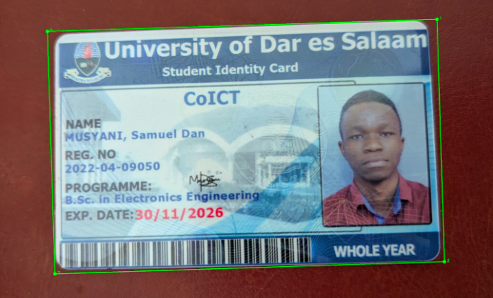
Figure 12: Sample card detected (green line shows detection)
- Anchor-based ROI localization, a known anchor label “NAME” within a corrected card image and isolate the region containing the registration number according to the relative offsets. The blue box shows the detection of the anchor label.
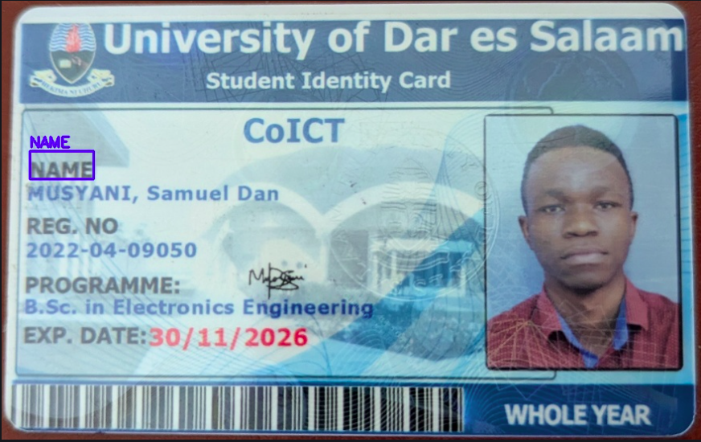
Figure 13: Anchor-ROI localization of sample card
- OCR extraction, validation and performance analysis, Tesseract OCR was used with prioritization of numeric recognition and validation of the extracted text against the institutional format. In addition to that, processing time and success message was extracted and logged into the system.
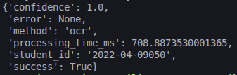
Figure 15: Text extraction and processing performances

4.2 CIRCUIT SIMULATION

4.2.1 REVERSE POLARITY CIRCUIT
Circuit simulation was done for electrical logic in the design using Proteus Design Suite (PDS). Power supply circuit which involved input protection with implementation of fuse and reverse polarity protection. This circuit simulation involved the use of MOSFET (P-channel) and a 15V Zener diode. The results for reverse polarity protection are as follows:
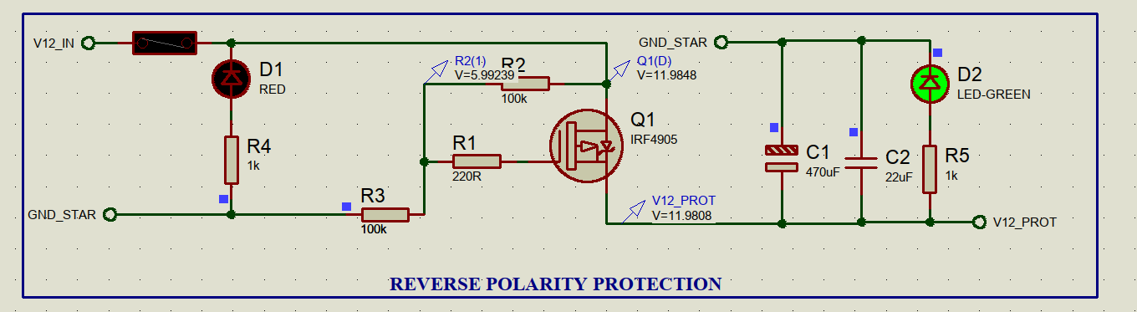
Figure 15: Correct input polarity
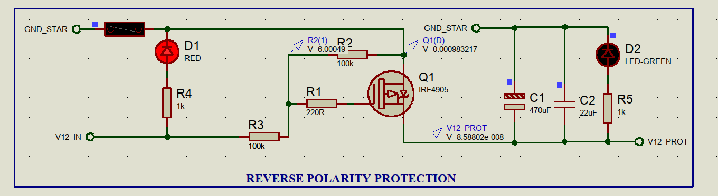
Figure 16: Wrong input polarity
As observed, in the correct polarity, the output node (V12_P) is set to 11.9808V which is expected. On the other side, the wrong polarity, the output node (V12_P) is set to 8.5588⁻⁸V which is very small close to zero. This means that the circuit’s reverse polarity protection works fine in the simulation.
Also, for the power supply, power rail separation was implemented to prevent interferences between the logic components and the motor parts. This is because the motor usually sink some various inrush currents which forms a problem to power sensitive components.

4.2.2 BUCK CONVERSION CIRCUITS
For LMZ23610 and TPSM82903, their simulation modules are not available in various simulation platforms. With other applications, no relevance of simulation results and the reality of the behaviour of such modules were recorded from the research. Therefore, WEBENCH Power Designer from Texas Instruments was used for design estimation on behaviours of the chosen modules.
For LMZ23610 module, there are two simulation done with that particular design circuit. The simulations are as explained below:
- At startup simulation; the module with its peripherals and external components connected is tested for peak currents and voltage and the overall behaviour of the module as shown below. The voltage rises at the power on moment will current slowly ramps up to 5A.
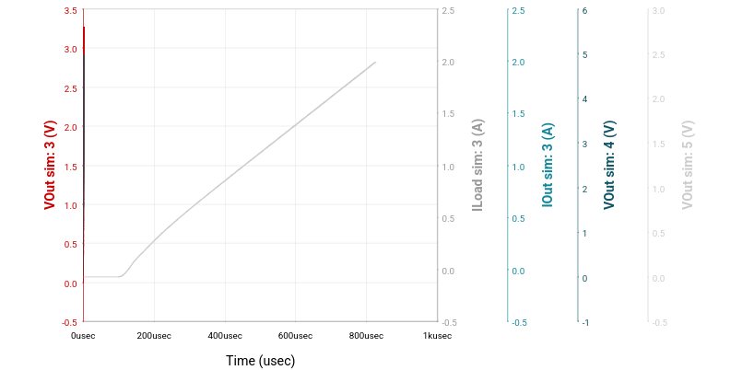
Figure 17: LMZ23610 simulation results at startup
- At steady state; the module was tested with steady state output condition, with clear observations on voltage descending to 5V exactly which is within the expected output ranges.
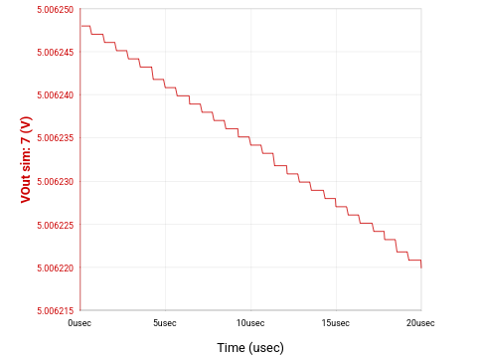
Figure 18: LMZ23610 simulation results at steady state
For TPSM82903 module also, there were two simulations done with that particular design circuit. The simulations are as explained below:
- At startup simulation; the module with its peripherals and external components connected is tested for peak currents and voltage and the overall behaviour of the module as shown below. The time to start giving out output voltage is controlled by the soft start pin which is usually connected to a capacitor, but in the designed schematic, it was not connected to ensure minimum start time as observed.
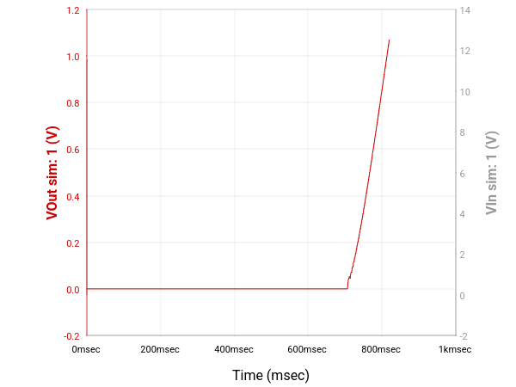
Figure 19: PTSM82903 simulation results at start up
- At load transient; the module was tested for transient at the load node. It is then observed in the simulation that as soon as the output voltage exceeds 3.6V, the currents drops significantly as this is a safety feature since the design served components of 3.3V only.
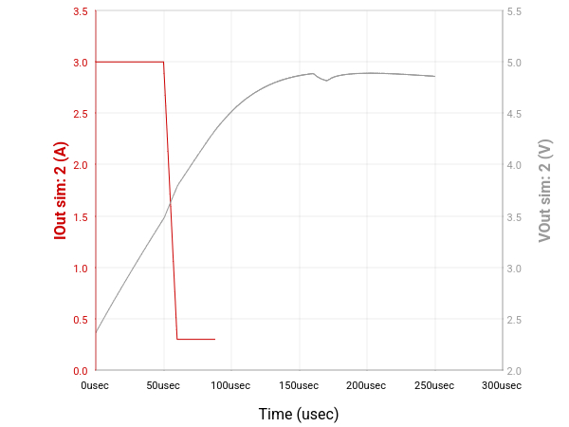
Figure 20: PTSM82903 simulation results at load transient

4.2.3 MOTOR DRIVER CIRCUIT SIMULATION
The designed schematic for custom motor driver using ULN2003A chip for driving a stepper motor was simulated using Proteus Design Suite (PDS) in order to observe and record the studied behaviour of the said module. The simulation was as follows:
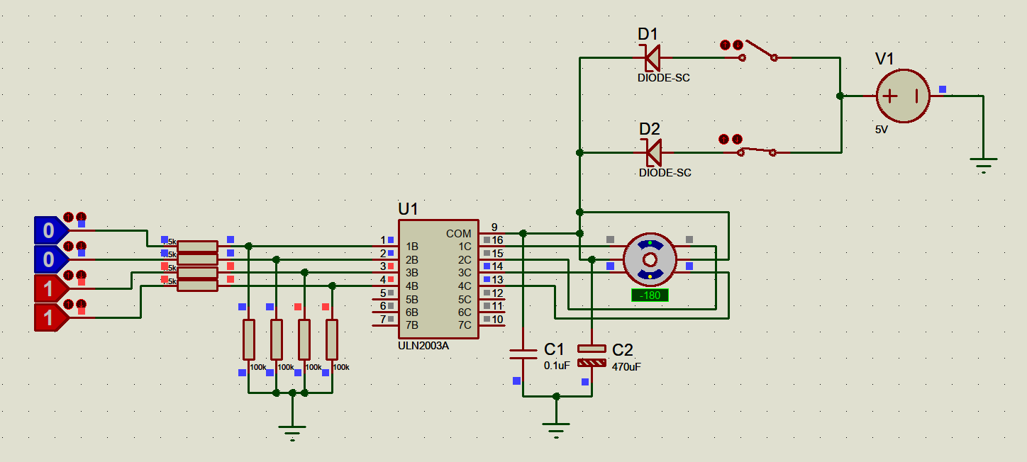
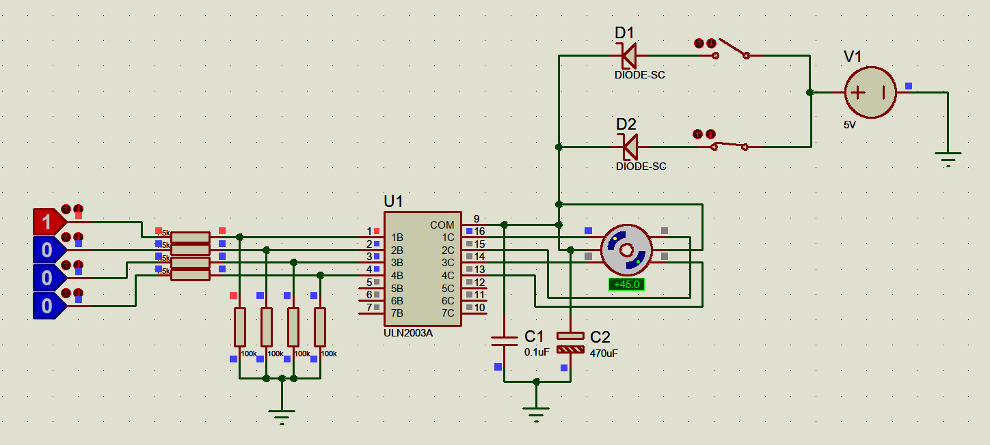
Figure 21: 0011 and 1000 test signals (from MCU) to motor driver
Since the motor driver will be driven by the STM32, the logic source signals were used to imitate the signals provided by the MCU at different intervals, and 0011 combination gave out -180° turn while 1000 combination gave out 45° turn on the stepper motor, according to the steps and respective angular displacement set. Thus, the connection of the motor driver circuit is electrically correct.

CHAPTER FIVE: CONCLUSION
At the end of the first semester, the project’s implemented parts are mostly software and electrical hardware simulations. Software implementations were performed prior to their hardware environment (high-level controller) because the environment used (Linux) is highly compatible to the environment with which the software will run in (Raspberry Pi OS). On the next chapter of progress, hardware facilities are expected to be available for proper implementation of computer vision, and for implementing the authentication with the backend running in the mentioned high-level controller.
Electrical hardware simulations of various power circuit components were conducted, yielding results that match closely to the theoretical results in each of the simulations. Therefore, the next progress goal is to physically obtain the electronic components and build the circuits for power supply implementation. Additionally, logics and communication interfaces will be integrated together with enclosure design and the mechanics to sort and distribute ID cards to individual students.

REFERENCES
- Ratnasri, Nilani & Sharmilan, Tharaga. (2021). Vending Machine Technologies: A Review Article. International Journal of Sciences: Basic and Applied Research (IJSBAR). 58. 160-166.
- Aman Prasad, Shraddha Kumar, Keshav Shriram, Prof. Dr. Vikram Mane, “IOT Based Pen Vending Machine”, Published in International Research Journal of Innovations in Engineering and Technology-IRJIET, Volume 8, Issue 3, pp 367-373, March 2024. Article DOI https://doi.org/10.47001/IRJIET/2024.803057
- Bai, Y., Hu, J., Liu, J., & Zhou, Q. (2012). Card transport device and ATM using same (U.S. Patent No. US8251282B2). U.S. Patent and Trademark Office.
- Instructables User “Joe_Squared”. (2017). DIY trading card dispenser project. Instructables.
- Peter Kibaya, Charles S Lubobya (2024) Design of a Multifactor Authentication System for Automated Teller Machines. 1: 1-17
- Xia, K., Fan, H., Huang, J., Wang, H., Ren, J., Jian, Q., & Wei, D. An Intelligent Self-Service Vending System for Smart Retail. Sensors, 21(10), 3560. https://doi.org/10.3390/s21103560

